The uploading of the SWEn Web application and database.

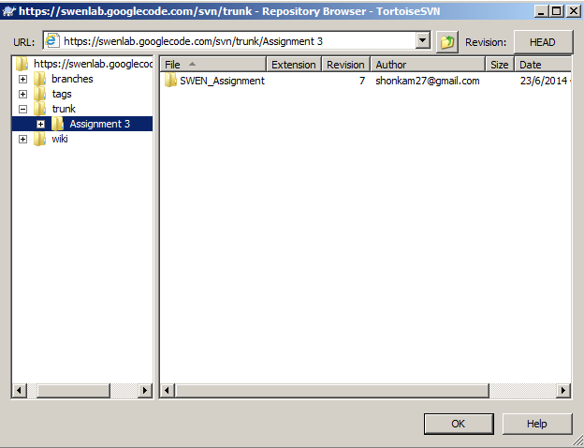

The uploading of the STS(Software Testing Specification)

